Bee Busters Save Wild Hive
May 11, 2014
David and Susan Payant, DBA the “The Bee Busters”, removed a feral hive from an office building this Saturday. The Bee Busters will remove feral hives and collect swarms for FREE, as long as they can keep the bees or give them to a good home.
We decided to form the Bee Buster business because we feel feral bees and swarm bees represent good genetic stock from which strong northern bees can be grown. Since honey bees are declining nationwide, we should save as many bees as we can. Also, we like the idea of free bees!
The Bee Busters received a call from a friend who knew of an office in Marquette that was being bothered by a feral honey bee hive. The office was the Met Life Office on Washington St. in Marquette. The property was owned by Houle and Associates, a CPA accounting firm. We contacted the owner and got his story as to the history of the hive.
Last June, a hive was discovered living in the walls of the Met Life office. The hive was located on the west wall of the brick building. In an effort to get rid of the bees, insecticide was sprayed into the hive. The bees decided to leave the west side of the building and built a new hive on the east wall. The office workers were quite disconcerted to see thousands of bees flying past the windows in their office.
After this winter, the hive was still alive in the east wall and bees were entering the Met Life office on a regular basis. Also, the dead brood comb in the west wall was stinking.
At the request of the landlord, we devised a plan to remove the bees by cutting into the wall from the inside. We had watched a number of feral hive removals on YouTube but none of them involved an inside entrance to a hive. Since the outside of this building was brick, inside removal was the only option.
We assembled every conceivable item we would need and even rehearsed some of our moves.
We decided to use some old mosquito netting from an old tent to cover where we would cut into the wall to get at the bees. I had a general idea where the bees were because I had banged on the wall and heard buzzing just below a window on the east side of the building. From the outside of the building, bees could be seen entering under the window ledge where the masonry had deteriorated.
We set up some sawhorses and then screwed some furring strips to the sawhorses. We draped the old tent over the frame and taped the tent to the wall to keep the bees confined while we removed the hive.
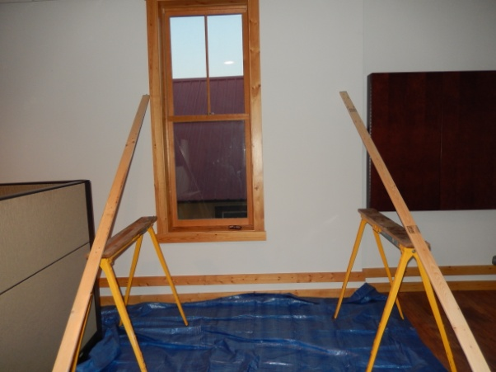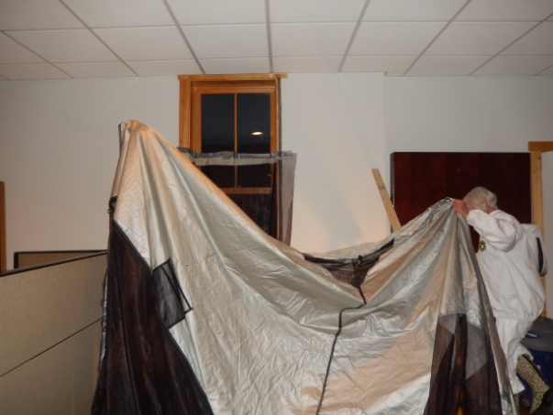
We decided to do the removal on a weekend so any bees that got into the office could be dealt with prior to the opening of business on Monday morning. We also chose a night removal time so the bees would be in the hive and not out foraging.
Matt and Cassie Anderson helped us. Matt cut into the wall. The wall was hollow and consisted of a layer of drywall and a layer of old plaster and lath. We had experienced much trepidation over the location of the hive. On the night of the removal, the bees would not buzz when we banged on the wall and listened with a stethoscope. We lucked out and found the entire hive right under the window.
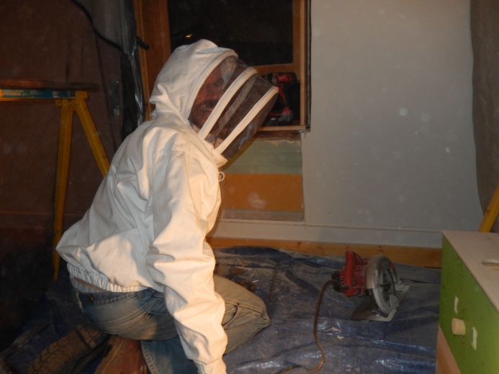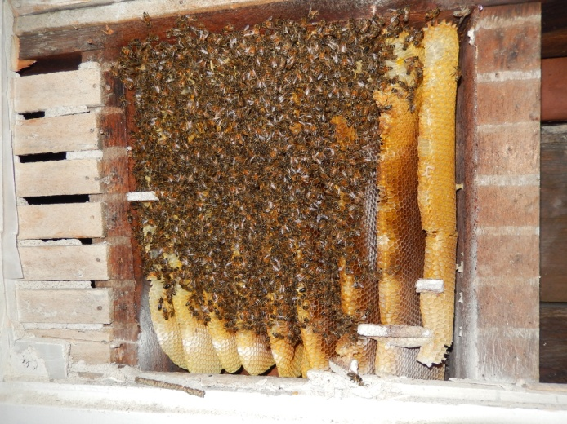
The bees were quite docile while we removed them. We took out the comb and put it in empty frames by using rubber bands to hold them in place. Our research indicated the bees will attach the comb to the frames and then will remove the rubber bands from the hive.
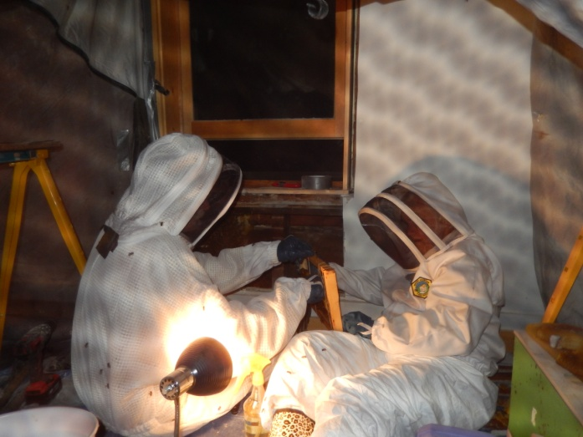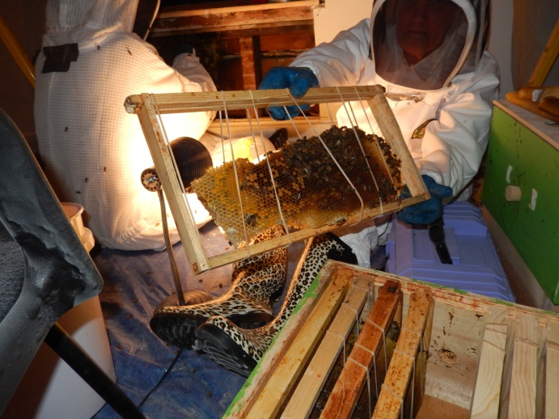
After the removal of the comb, I used a bee vacuum which I had made to remove the remaining bees from the wall cavity. Contrary to some reports, the death rate of the vacuumed bees was minimal. The only trauma to the bees was a number died due to the plaster dust that was created by the sawing into the old fashioned plaster. I think this old plaster is made partly of lime and so in quite caustic.
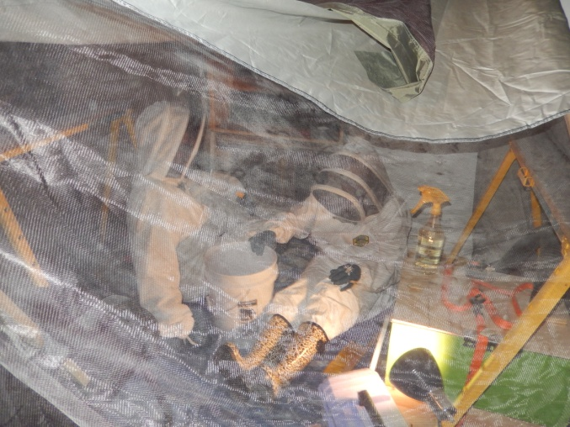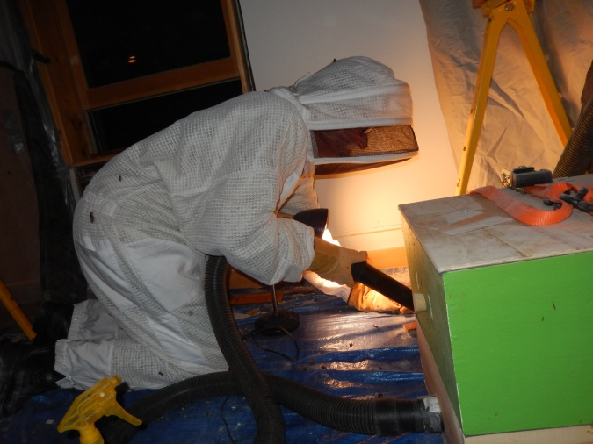
We were surprised at the small number of bees in the hive. Despite there being 9-10 combs with an area near that of standard 10 frame deep, only a few thousand bees were in the hive and only a couple of hundred capped brood. We put the hive in our bee yard adjacent to the West Branch of the Escanaba River. They were flying this Sunday and it appears we got the queen. When we poured the bee vacuumed bees out, they all went right to the hive I believe because they scented the queen.
Susan and I intend to collect more swarms and feral bees over the summer but we intend to give them away as we are awash in bees right now. If you are interested in a swarm, contact us or the Superior Beekeeping Club.
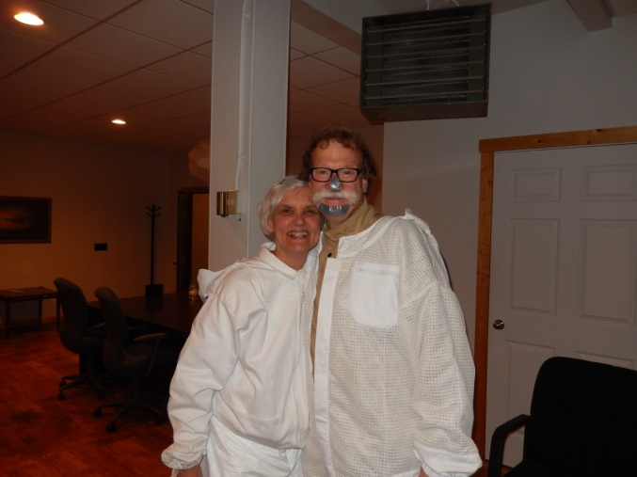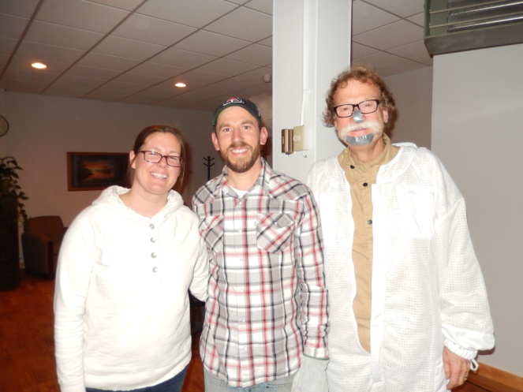
Susan and David Payant Cassie and Matt Anderson

